**Automated ECG Classification Using Deep Learning Framework**

**Abstract:**

This project presents a novel computational framework for cardiac arrhythmia classification that combines particle swarm optimization with convolution neural networks. The proposed system automatically optimizes neural network architectures for analyzing ECG signals to detect and classify multiple types of cardiac arrhythmias. The framework introduces a particle swarm optimization approach that autonomously determines optimal hyper parameters for the CNN architecture, eliminating the need for manual configuration. By leveraging the MIT-BIH Arrhythmia Dataset, the system demonstrates robust performance in classifying five distinct types of cardiac arrhythmias. The integration of evolutionary algorithms with deep learning enables automatic architecture optimization while maintaining high classification accuracy and minimizing categorical cross-entropy error. This innovative approach represents a significant advancement in automated ECG analysis by removing the dependency on manual hyper parameter selection, making it particularly valuable for clinical applications where expert knowledge of neural network design may be limited.

**Objectives:**

* To develop an innovative hybrid framework that combines particle swarm optimization with convolution neural networks for accurate cardiac arrhythmia classification.
* To design and implement an automated hyper parameter optimization system that eliminates manual architecture configuration while maintaining classification performance.
* To create an efficient system that minimizes categorical cross-entropy error while providing robust arrhythmia detection across multiple classes.
* To validate the framework's effectiveness through comprehensive testing on standard ECG datasets and establish its reliability as a diagnostic support tool.

**Existing System:**

Traditional machine learning approaches have been the foundation of ECG analysis for many years. Support Vector Machines (SVM) have been widely implemented in hospitals and clinics, using mathematical boundaries to separate different types of heart rhythms. However, these systems require extensive manual work in feature engineering, where experts must identify and extract relevant patterns from the ECG signals. Similarly, decision trees and random forests have gained popularity due to their easy-to-understand nature, presenting results in a way that medical professionals can interpret. Yet, they struggle when faced with complex ECG patterns that don't fit their rigid decision-making structure. K-Nearest Neighbors (KNN) methods have also been used, offering a straightforward approach to classification, but they become impractical and inefficient when dealing with large amounts of patient data.

**Proposed System:**

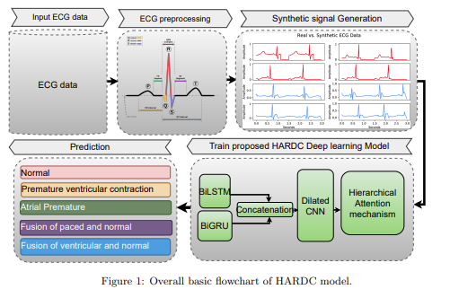

The healthcare industry faces significant challenges in accurately detecting and classifying cardiac arrhythmias through ECG analysis. Current systems heavily depend on both medical expertise for interpretation and technical knowledge for system configuration, creating a substantial bottleneck in healthcare delivery. Traditional approaches require extensive manual tuning of machine learning parameters or deep learning architectures, making them impractical for many healthcare facilities that lack specialized AI expertise. This limitation often forces medical institutions to either invest heavily in technical specialists or rely on less sophisticated analysis tools that may miss critical cardiac patterns, potentially affecting patient care quality and diagnosis speed.

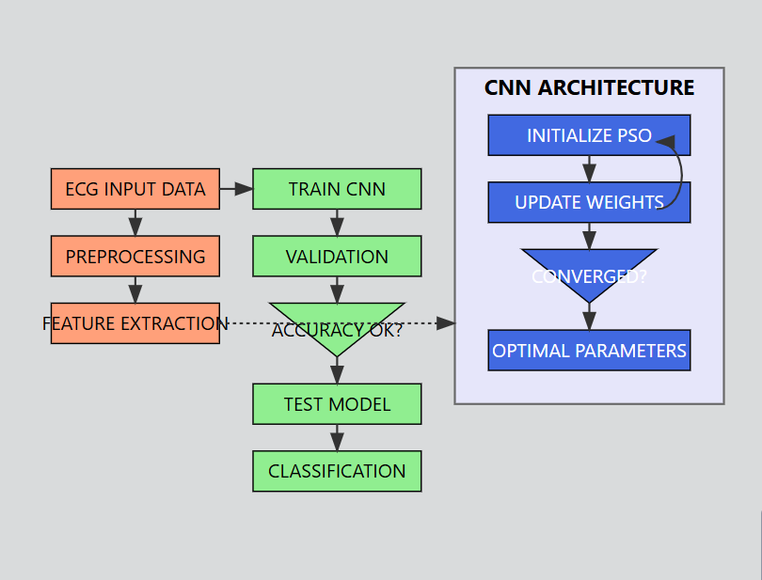

Moreover, existing automated ECG analysis systems struggle with adaptability across different patient conditions and arrhythmia types. The fixed nature of current neural network architectures means they often can't maintain consistent accuracy across diverse patient populations without significant manual reconfiguration. This inflexibility, combined with high computational requirements and resource costs, creates practical implementation challenges for healthcare facilities, particularly smaller ones with limited resources. The lack of a self-optimizing system that can automatically adjust its architecture while maintaining high accuracy represents a critical gap in cardiac care technology, highlighting the urgent need for a more adaptive and efficient approach to ECG analysis that minimizes the need for manual intervention while ensuring reliable diagnostic support.

**SYSTEM REQUIREMENTS**

**Hardware Requirements**

1. **Processor**: Multi-core CPU (Intel i7 or equivalent) with GPU support (NVIDIA RTX series or higher recommended for deep learning).
2. **Memory**: Minimum 16 GB RAM (32 GB preferred for large-scale training).
3. **Storage**:
   * At least 1 TB HDD or 512 GB SSD for datasets, models, and logs.
   * Additional storage for backups.
4. **GPU**:
   * NVIDIA CUDA-enabled GPU with at least 8 GB VRAM (e.g., NVIDIA RTX 3060 or higher).

### ****Software Requirements****

**Operating System**

* + Windows 10/11, macOS, or Linux (Ubuntu 20.04 or higher recommended for compatibility with most ML tools).

**Programming Languages**

* Python (v3.7 or higher)

**Libraries and Frameworks**

1. **Deep Learning Frameworks**:
   * TensorFlow (v2.x)
   * PyTorch (v1.x or higher)
2. **ECG Processing Libraries**:
   * WFDB Toolbox (Waveform Database Toolbox)
   * NeuroKit2